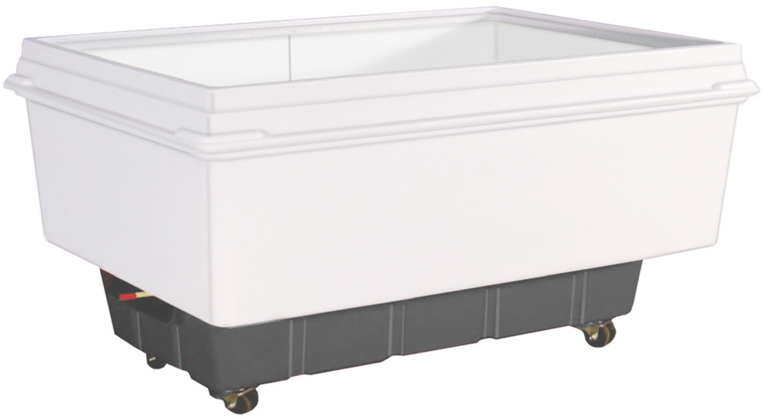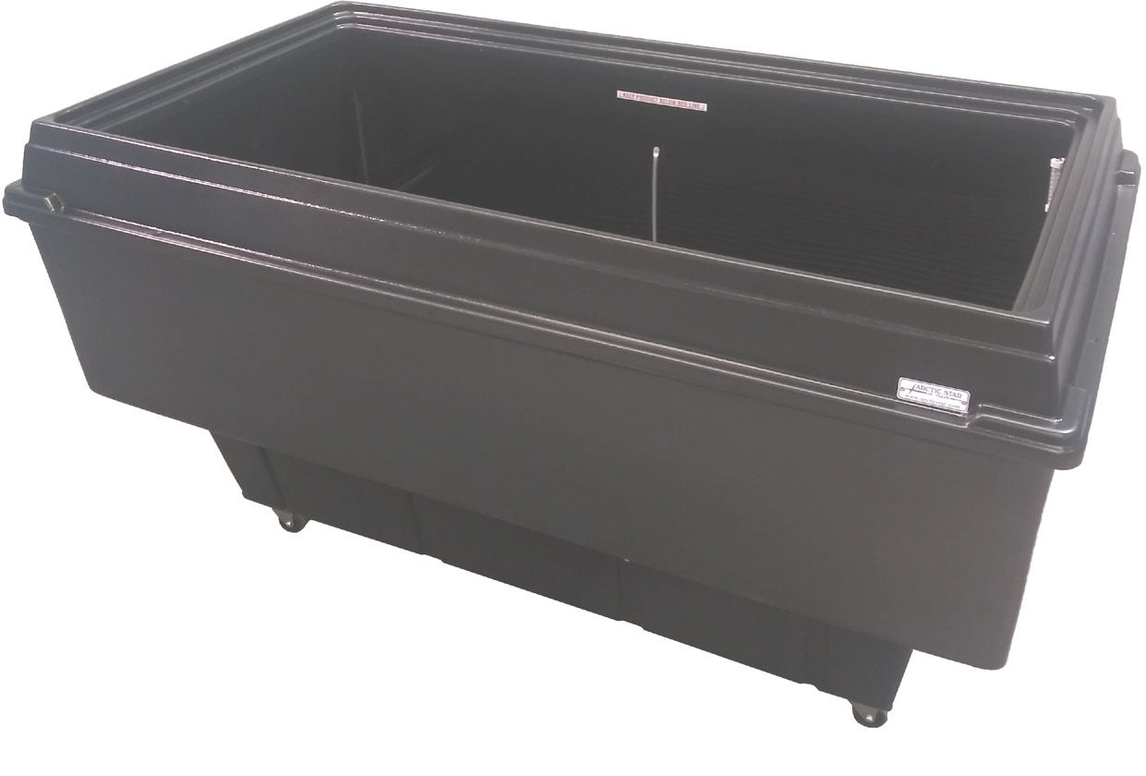

**06**

[**www.arcticstar.com**](http://www.arcticstar.com/)

**AS-16**

**Spot Cooler for greater impulse sales**

A large capacity refrigerated unit to add more product and can also be moved easily to any department.

Voltage 115/60/1 Plug Type NEMA-5-15P Amperes 7.5

Compressor HP 3/8 Cord Length 6

Refrigerant 134-A

Length 63”

Width 35”

Height 34”

Length 55”

Width 27”

Depth 15”

Black Black/White

**Get in touch with our Business Manager:**

3540 West Pioneer Parkway, Arlington, TX, 76013

Tel. (817) 274-1396

[info@arcticstar.com](mailto:info@arcticstar.com)

**Product visibility from top**

**Molded durable plastic**

**Features:** 16 cubic foot capacity, Compressor 1/3 HP-115 volts, No lid required, mobile w/ casters, molded durable plastic, surface for branding.

**Color**

**Interior**

**Exterior**

**Electrical Data**